W0000 Existing Inventory and/or Current VRI Assessment Report – Example 1

Purpose of assessment: To determine whether a new AAC should be proposed
Existing Inventory (inventory used in most recent long term AAC determination in current MP)
Date: May 1990
Source: FC 1 and cruise information for some polygons
Photo Interpreter: not applicable
Field Assessor: Joe Logger

Current VRI
Reference Year: Jan 2015
Imagery Date: 2009
Projection Year: 2016
Name of Photo Interpreter: unknown

Other information considered (check all that apply):
any new imagery available? If yes, date:
current condition of forests
type and nature of disturbance events
volume of timber billed since last AAC determination
any fieldwork undertaken? If yes, date: April 10-15, 2016 and # of polygons visited: 10
other? If yes, please specify:

Methods used to assess existing inventory and/or current VRI: Existing inventory reviewed against current VRI with fieldchecks of 10 randomly selected polygons done to see whether either inventory adequately represented the ground.

Assessment Statement/Conclusion (select one):
existing inventory is adequate once updated for recent disturbances
current VRI is more appropriate once updated for recent disturbances
existing inventory needs improvements as described here:
current VRI needs improvements as described here:

Brief Rationale for Statement/Conclusion: Based on fieldwork, the existing inventory's polygon delineation and attributes did not represent the current condition of the forest. The current VRI delineation and attributes were found to be suitable to a level of reliability that would support timber supply modelling; however, updates for recent disturbances will be required. Silviculture surveys are scheduled for the spring of 2017.

New AAC to be proposed in new MP: Y N
If Y, Timber Supply Model to be used: Woodlot for Windows Version 4.3
If N, explanation:

Prepared by: Joe Forester Date: Feb 8, 2017
Professional Signature & Seal:
W9999 Existing Inventory and/or Current VRI Assessment Report – Example 2

Purpose of assessment: To determine whether the existing AAC is sustainable
To determine whether a new AAC should be proposed
Existing Inventory (inventory used in most recent long term AAC determination in current MP)
Date: June 2001
Source: 2000 VRI using 1998 imagery with 1994 & 1999 cruise data used for some polygon attributes
Photo Interpreter: Joe Interpreter
Field Assessor: Joe Forester

Current VRI
Reference Year: Jan 2016
Imagery Date: 2009
Projection Year: 2017
Name of Photo Interpreter: unknown

Other information considered (check all that apply):
any new imagery available? If yes, date: 2014
current condition of forests
type and nature of disturbance events
volume of timber billed since last AAC determination
any fieldwork undertaken? If yes, date: June 25-26, 2017 and # of polygons visited: 12
other? If yes, please specify:

Methods used to assess existing inventory: Existing inventory reviewed against current VRI with fieldchecks of 12 polygons done to see whether either inventory adequately represented the ground.

Assessment Statement/Conclusion (select one):
existing inventory is adequate once updated for recent disturbances
current VRI is more appropriate once updated for recent disturbances
existing inventory needs improvements as described here:
current VRI needs improvements as described here: Polygon delineation is appropriate but will require updating for recent disturbances. Polygon attributes for young pine stands and some mature spruce stands were not representative of field findings or photo intrepretation of newer imagery. Recent disturbances will require updating.

Brief Rationale for Statement/Conclusion: The volume of timber billed since the last AAC determination far exceeded the sustainable AAC calculated from the existing inventory due to clearcutting and selective logging of the mountain pine beetle in mixed stands. Based on fieldwork and photo interpretation of new imagery, the current VRI's polygon delineation and attributes better represent the current condition of the forest; however, improvements are required to attributes in some stand types. Additional fieldwork in these stand types is scheduled for the fall of 2017 when silviculture surveys will be conducted to update VRI information for recent disturbances.

New AAC to be proposed in new MP: Y N
If Y, Timber Supply Model to be used: Woodlot for Windows Version 4.3
If N, explanation:

Prepared by: Jane Forester Date: July 5, 2017
Professional Signature & Seal:

W0000 Inventory Plan – Example 1

Scope
- Lands subject to inventory (select one and fill in all info for that line):
only private: all or only portions (provide description):
only Crown: all or only portions (provide description):
both private and Crown: all or only portions (provide description):

- Focus of inventory (check all that apply and provide example or brief description):
current forest conditions:
current boundaries:
catastrophic event:
recent disturbance updates: harvesting
systemic error:
other? If yes, please specify:

- Other stand attributes required by the district manager or desired by the licensee (please specify): n/a

Method
- Type of Inventory (select one):
- Use Existing Woodlot Inventory
- Use Current VRI
- Use Polygons and Change Attributes from the Existing Woodlot Inventory
- Use Polygons and Change Attributes from the Current VRI
- Change Polygons and Attributes from the Existing Woodlot Inventory
- Change Polygons and Attributes from the Current VRI

- Rationale for type selected: As per the Feb 8, 2017 Inventory Assessment, the current VRI delineation and attributes were found to be suitable to a level of reliability that would support timber supply modelling; however, updates for recent disturbances are required.

- Standards and/or specifications to be used (for types 3 to 6, if selected under A above): n/a

- Describe methods to be used to ensure recent disturbance updates are reflected in the new inventory (required for all inventory types): New disturbance areas will be gps'd and cut into the VRI dataset and labelled as NSR. RESULTS spatial data that does not exist in the current VRI will be cut into the VRI dataset. Inventory layer data in RESULTS and/or from new silviculture surveys will be used to update VRI information for all blocks (clearcuts).

- Describe the procedures for any planned photo interpretation: n/a

- Describe the procedures for any planned fieldwork: conduct silviculture surveys (planting, regen, or free growing) on all non-declared free growing clearcuts where information is missing or outdated in RESULTS.

- Estimate the timelines for completing the planned inventory work
Inventory Work Milestones | Estimated Timeline
1. Polygon Delineation | n/a
2. Sampling Plan | n/a
3. Fieldwork (data collection & compilation) - silv surveys | Apr 2017
4. Polygon Attribute Assignment | n/a
5. Compilation of Inventory Work | n/a
6.
(licensee and professional may choose which milestones are appropriate in their situation, and they may identify other milestones)

- Request FLNRORD review:
at the end of each phase or at the end of phase(s) or at final submission only

Prepared by: Joe Forester Date: Mar 12, 2017
Professional Signature & Seal:
W9999 Inventory Plan – Example 2

Scope
- Lands subject to inventory (select one and fill in all info for that line):
only private: all or only portions (provide description):
only Crown: all or only portions (provide description):
both private and Crown: all or only portions (provide description):

- Focus of inventory (check all that apply and provide example or brief description):
current forest conditions: existing inventory not representative
current boundaries:
catastrophic event: mountain pine beetle
recent disturbance updates: logging activities
systemic error: young pine stands mislabelled as mature fir; heights of mature spruce stands
other? If yes, please specify:
- Other stand attributes required by the district manager or desired by the licensee (please specify): n/a

Method
- Type of Inventory (select one):
- Use Existing Woodlot Inventory
- Use Current VRI
- Use Polygons and Change Attributes from the Existing Woodlot Inventory
- Use Polygons and Change Attributes from the Current VRI
- Change Polygons and Attributes from the Existing Woodlot Inventory
- Change Polygons and Attributes from the Current VRI

- Rationale for type selected: As per the Jul 5, 2017 Inventory Assessment Report, the current VRI's polygon delineation and attributes better represent the current condition of the forest; however, improvements are required to attributes in some stand types.

- Standards and/or specifications to be used (for types 3 to 6, if selected under A above): The standards/specifications in the 2018 Woodlot Inventory Handbook will be followed.

- Describe methods to be used to ensure recent disturbance updates are reflected in the new inventory (required for all inventory types): RESULTS opening boundaries not included in the VRI delineation will be cut into the VRI dataset. More recent block boundaries will be gps'd during silviculture surveys and then cut into the VRI dataset, if different than the VRI delineation. Any resultant multipart polygons will be dissolved to eliminate any polygons < 0.2 ha in size. Forest cover inventory layer data in RESULTS and/or from new silviculture surveys will be used to update VRI information for all clearcut blocks or openings in group selection blocks. Partial cut or single tree selection blocks will use the layer one forest cover inventory data from RESULTS or silviculture surveys to update the VRI information.

- Describe the procedures for any planned photo interpretation: n/a

- Describe the procedures for any planned fieldwork: A sampling plan and map will be submitted prior to any planned fielwork. The sampling plan will outline the types and number of planned plots for each polygon to be visited and the data to be collected at each plot.

- Estimate the timelines for completing the planned inventory work
Inventory Work Milestones | Estimated Timeline
1. Polygon Delineation | n/a
2. Sampling Plan | Aug 10, 2017
3. Fieldwork (data collection & compilation) | Sep 10-30, 2017
4. Polygon Attribute Assignment | Oct 14-16, 2017
5. W4W wlt data entry | Nov 5-7, 2017
6. Completion of Inventory Work | Nov 28-30, 2017
(licensee and professional may choose which milestones are appropriate in their situation, and they may identify other milestones)

- Request FLNRORD review:
at the end of each phase or at the end of phase(s) or at final submission only

Prepared by: Jane Forester Date: July 5, 2017
Professional Signature & Seal:
W0000 Inventory Work Summaries – Example 1

Recent Disturbance Updates Summary:
- Logging Activity Disturbances: 2 new polys 5 RESULTS polys or not applicable (no recent logging)
polygon information from: RESULTS silviculture surveys other - please specify 2 new polys are NSR
- Natural Disturbances: new polys or not applicable (no recent significant disturbances)
Process used:

Polygon Delineation Summary: below or not applicable (no changes to delineation except recent disturbances)
- Photo Interpreter - Name: , Experience: , Qualifications:
- Imagery Description:
  - Type: digital photos hardcopy photos satellite imagery drone imagery
  - Date(s): and Scale(s):
- Stereoscopic Method: hardcopy softcopy
- Actual Fieldwork Description not applicable or see below:
  - Polygons visited in support of photo interpretation: see attached map (& legend)
  - Photo interpreter participated in field work as identified here:
- Polygons that significantly changed from current VRI and/or existing inventory delineation:
see attached map (& legend) or see attached summary table

Polygon Attribute Interpretation Summary: below or not applicable (no changes to attributes)
Attributes derived from? both photo interp and fieldwork or photo interpretation or fieldwork

Fill in the appropriate information based on your selection above:
- Photo Interpreter - Name: , Experience: , Qualifications:
- Imagery Description:
  - Type: digital photos hardcopy photos satellite imagery drone imagery
  - Date(s): and Scale(s):
- Stereoscopic Method: hardcopy softcopy
- Field Assessor - Name: , Experience: , Qualifications:
- Actual Fieldwork Description:
  - Type(s): full measure plots count plots other - please specify:
  - Amount (# of plots for each type):
  - Attributes collected (how?):
  - Polygons visited: how many? & when (month/year)?
  - Polygons visited in support of attribute changes: identified on attached map
  - Rationale used to visit all or only a selection of polygons:
  - Actual plot locations: see attached map
  - Field Assessor participated in field work as identified here: polygons
  - Photo interpreter participated in field work as identified here: polygons
- Fieldwork Compilation Description (based on or calculated from):
  - Species Composition: basal area other - please specify:
  - Avg Age: : measured dom & codom for leading species other - please specify
  - Avg Height: : measured dom & codom for leading species other - please specify
  - Avg Stand Density: live & dead stems/ha separately other - please specify
  - Avg SI: Avg SI from leading species ages & heights SIBEC other - please specify:
- Polygons that significantly changed from current VRI and/or existing inventory attributes:
see attached map or see attached summary table

Inventory Products submitted or only first 5 submitted (no changes except disturbance updates):
Select all that apply (first 5 required; others depend on Inventory Method used):
- Inventory Assessment Report
- Inventory Plan
- Digital georeferenced PDF map file of new inventory
- Georeferenced spatial and attribute data set (ie. shapefile) of new inventory
- Summary table of key attributes for each polygon of new inventory – identify updated data
- Sample Plan
- Copies of imagery used and polygon delineation outlines, if applicable
- Copies of fieldwork plot cards
- Georeferenced data set of the location of the actual measured field plots
- Summary table of polygon attributes & list of plots used to derive those attributes
- Excel table listing old and new data for all polygons with changed attributes
- If available, digital georeferenced PDF map & spatial/attribute data set of existing timber inventory

Prepared by: Joe Forester Date: June 1, 2017
Professional Signature & Seal:
W9999 Inventory Work Summaries – Example 2

Recent Disturbance Updates Summary:
- Logging Activity Disturbances: 5 new polys 6 RESULTS polys or not applicable (no recent logging)
polygon information from: RESULTS silviculture surveys other - please specify
- Natural Disturbances: new poly(s) or not applicable (no recent significant disturbances)
process used to update: or rationale for not updating

Polygon Delineation Summary: below or not applicable (no changes to delineation except recent disturbances)
- Photo Interpreter - Name: , Experience: , Qualifications:
- Imagery Description:
  - Type: digital photos hardcopy photos satellite imagery drone imagery
  - Date(s): and Scale(s):
- Stereoscopic Method: hardcopy softcopy
- Actual Fieldwork Description below or not applicable :
  - Polygons visited in support of photo interpretation: identified on attached map
  - Photo interpreter participated in field work as identified here: polygons
- Polygons that significantly changed from current VRI and/or existing inventory delineation:
see attached map or see attached summary table

Polygon Attribute Summary: below or not applicable (no changes to attributes)
Attributes derived from? both photo interp and fieldwork or photo interpretation or fieldwork
Fill in the appropriate information based on your selection above:
- Photo Interpreter - Name: Joe Interpreter, Experience: 15 years, Qualifications: certified interpreter
- Imagery Description:
  - Type: digital photos hardcopy photos satellite imagery drone imagery
  - Date(s): Aug 2014 and Scale(s): 1:50 000
- Stereoscopic Method: hardcopy softcopy
- Field Assessor - Name: Joe Technician, Experience: 10 yrs, Qualifications: cruising for ForTech Ltd
- Actual Fieldwork Description:
  - Type(s): full measure plots count plots other - please specify: walkthroughs
  - Amount (# of plots for each type): 27 full measure and 10 count
  - Attributes collected (how?): Variable radius plots were established with a BAF selected to capture 6-8 trees per plot - 1 BAF per polygon. A minimum of 1 suitable sample tree was selected at each plot with a minimum of 3 per polygon. Data collection as per standards in 2018 Woodlot Inventory Handbook. See attached spreadsheet.
  - Polygons visited: how many? 9 & when (month/year)? September 2017
  - Polygons visited in support of attribute changes: identified on attached map
  - Rationale used to visit all or only a selection of polygons: Based on the Jul 5, 2017 Inventory Assessment Report, only mature spruce polygons were selected for additional fieldwork.
  - Actual plot locations: see attached map
  - Field Assessor participated in field work as identified here: polygons 1-3, 15, 25-27, 42, & 108
  - Photo interpreter participated in field work as identified here: polygons 3, 25, 42, & 108
- Fieldwork Compilation Description (based on or calculated from):
  - Species Composition: basal area other - please specify:
  - Avg Age: : measured dom & codom for leading species other - please specify
  - Avg Height: measured dom & codom for leading species other - please specify
  - Avg Stand Density: live & dead stems/ha separately other - please specify
  - Avg SI: Avg SI from leading species ages & heights SIBEC other - please specify: site productivity layer
- Polygons that significantly changed from current VRI and/or existing inventory attributes:
see attached map or see attached summary table

Inventory Products submitted or only first 5 submitted (no changes except disturbance updates):
Select all that apply (first 5 required; others depend on Inventory Method used):
- Inventory Assessment Report
- Inventory Plan
- Digital georeferenced PDF map file of new inventory
- Georeferenced spatial and attribute data set (ie. shapefile) of new inventory
- Summary table of key attributes for each polygon of new inventory – identify updated data
- Sample Plan & Map
- Copies of imagery used and polygon delineation outlines, if applicable
- Copies of fieldwork plot cards
- Georeferenced data set of the location of the actual measured field plots
- Summary table of polygon attributes & list of plots used to derive those attributes
- Excel table listing old and new data for all polygons with changed attributes
- If available, digital georeferenced PDF map & spatial/attribute data set of existing timber inventory

Prepared by: Jane Forester Date: December 7, 2017
Professional Signature & Seal:
Woodlot Inventory Management Plan Information – examples

MP Section 3.1 Timber Resources Inventory:

Example 1 (Joe Forester) – Inventory Type 2 – Use Current VRI

There is no Private (Schedule A) land associated with Woodlot W0000.

An inventory assessment that included fieldwork done in the spring of 2016 concluded that the current VRI is adequate once updated for recent disturbances.

The current forest inventory information for the Crown land portion (Schedule ‘B’) of the Woodlot Licence W0000, is shown in Appendix I and on the map in Appendix III. The new inventory was completed on June 1, 2017 and is based on the 2015 VRI data which used 2009 imagery projected to January 1, 2016, with June 2015 updates for most openings in RESULTS. Seven recent disturbances required updating – 3 with RESULTS data from 2016, 2 with April 2017 silviculture survey data, and 2 were NSR.

This inventory will be updated as disturbances and other changes occur on the licence area. Updated information will be provided with the next revision to the management plan.

Example 2 (Jane Forester) – Inventory Type 3 – Use Polygons and Change Attributes

An inventory assessment that included photo interpretation and fieldwork done in the summer of 2017 concluded that the current VRI polygon delineation is appropriate but VRI attributes for some polygons required changes.

The current forest inventory information for the Crown land portion (Schedule ‘B’) and the private land portion (Schedule ‘A’) of the Woodlot Licence W9999, is shown in Appendix I and on the map in Appendix III.

The inventory is based on the 2016 VRI polygon delineation which used 2009 imagery, with June 2017 updates for most openings in RESULTS. Eleven recent disturbances required delineation updating – 6 with RESULTS spatial data that was absent from the current VRI; 3 with new and more accurate gps data from September 2017 silviculture surveys; and 2 with gps data from September 2017 silviculture surveys for new blocks not yet reported to RESULTS.

Of the 112 polygons in the inventory, the attributes for 84 polygons are based on the 2016 VRI projected to January 1, 2017, with June 2017 updates for most openings in RESULTS; 17 polygons are based on new photo interpretation of 2014 imagery and fall 2017 fieldwork; 5 polygons (blocks) are based on surveys conducted in the fall of 2017; and the 6 RESULTS openings missing from VRI are based on RESULTS data from 2012 and 2015.

This inventory will be updated as disturbances and other changes occur on the licence area. Updated information will be provided with the next revision to the management plan.

MP Section 5.0 Proposed Allowable Annual Cut:

Example 1 (Joe Forester)
Proposed Allowable Annual Cut (AAC) for Woodlot Licence W0000 is:

Schedule A lands: n/a m3 per year
Schedule B lands: 2200 m3 per year

A Volume Calculation report has been attached in Appendix I using the model WOODLOT for Windows Version 4.3 with base year set to 2016. Inventory supporting documents are attached as Appendix II.

Example 2 (Jane Forester)
Proposed Allowable Annual Cut (AAC) for Woodlot Licence W9999 is:

Schedule A lands: 100 m3 per year
Schedule B lands: 1000 m3 per year

A Volume Calculation report has been attached in Appendix I using the model WOODLOT for Windows Version 4.3 with base year set to 2017. Inventory supporting documents were submitted previously under separate cover.

MP Appendix I – W4Ws Volume Calculation Report – Introduction section*:
Example 1 (Joe Forester)

The general differences between the existing and new inventories of W0000 are the updates for recent disturbances. The new inventory was completed on June 1, 2017 and is based on the 2015 VRI data which used 2009 imagery projected to January 1, 2016, with June 2015 updates for most openings in RESULTS. Seven recent disturbances required updating – 3 with RESULTS data, 2 with April 2017 silviculture survey data, and 2 were NSR. Base Year of 2016 was used in the model because new growth had not yet occurred for the 2017 season when surveys were conducted. Current ages were adjusted in W4Ws based on this base year and the reference year of the forest cover inventory layer information which was used for recent disturbance updates.

MP Appendix I – W4Ws Volume Calculation Report – Introduction section*:
Example 2 (Jane Forester)

The general differences between the existing and new inventories of W9999 are: species composition, basal area, density (stems/ha), site index, and spruce heights.

The existing inventory for W9999 is based on the 2000 VRI data that used 1998 imagery, as well as, 1994 & 1999 cruise data updates for some polygon attributes. Like inventories of that era, the existing inventory does not include basal area or density (stems/ha) – two important factors in the W4W’s version 4.3. In the 17 years since the compilation of this existing inventory, extensive changes have occurred to the landbase due to clearcutting and selective logging of the mountain pine beetle in pure and mixed stands, as well as, removal of green timber under regular cutting permits.

The new inventory is based on the 2016 VRI which used 2009 imagery, with June 2017 updates for most openings in RESULTS, as well as, updates to some polygons based on newer 2014 imagery supported by 2017 fieldwork or 2017 silviculture surveys or existing RESULTS data. The updated polygons resulted in higher site indices due to increased heights for mature spruce stands, appropriate species composition for young pine/fir stands, as well as, the use of SIBEC for immature stands (< 20 years old) and overmature stands (> 150 years old).

New disturbance areas were gps'd and cut into the VRI dataset and labelled as NSR. RESULTS spatial data that did not exist in the current VRI was cut into the VRI dataset. Block boundaries of older openings were gps'd during silviculture surveys and then cut into the VRI dataset, if different than the VRI delineation. Any resultant multipart polygons were dissolved to eliminate any polygons < 0.2 ha in size.

Polygon Delineation: The new inventory is based on the 2016 VRI polygon delineation which used 2009 imagery, with June 2017 updates for most openings in RESULTS. Eleven recent disturbances required delineation updating – 6 with RESULTS spatial data that was absent from the current VRI; 3 with new and more accurate gps data from September 2017 silviculture surveys; and 2 with gps data from September 2017 silviculture surveys for new blocks not yet reported to RESULTS.

Polygon Attributes: Of the 112 polygons in the inventory, the attributes for 84 polygons are based on the 2016 VRI projected to January 1, 2017, with June 2017 updates for VRI RESULTS openings; 17 polygons are based on new photo interpretation of 2014 imagery and fall 2017 fieldwork; 5 polygons (blocks) are based on surveys conducted in the fall of 2017, including 2 new disturbance areas; and the 6 RESULTS openings missing from VRI are based on RESULTS data from 2012 and 2015.

New attributes assigned to the 17 undisturbed polygons are based on field measurements and compilations done on 9 polygons which supported photo interpretation of the 8 others. Basal area and stems/ha only include live trees. Species composition is based on basal area. Average age and height is based on measured ages and heights for the leading species in each polygon. Site index is based on the average age and height of the polygon; or SIBEC if stand age is greater than 150 years old. Raw data and calculations were submitted as supporting documents.

Forest cover inventory layer data in RESULTS and/or from new silviculture surveys was used to update VRI information for all clearcut blocks or openings in group selection blocks. For blocks where planting was done for the entire NAR, RESULTS total planting density per hectare was used for initial density in TIPSY. For blocks where reforestation was by natural regeneration, RESULTS forest cover total stems per hectare was used for initial density in TIPSY. Partial cut or single tree selection blocks used the layer one forest cover inventory data from RESULTS or silviculture surveys to update the VRI information; except for 4 polygons where the majority of stems were in layer 2 or 3 (for further details, see comments section of harvest rate report).

Using the above information, reference ages and heights, as well as, basal area, stems/ha, and site index (if SIBEC) were updated in W4W’s polygon view. Reference dates were updated in W4Ws tabular view using completion dates from RESULTS forest cover survey information, new silviculture surveys, or new inventory plots/photo interpretation. Current stand ages were entered in tabular view after being calculated as follows:
Project Base Year | – | Reference Year | + | Average Age | = | Current Age
(from W4W) |  | (from RESULTS FC or new survey/plot/photo interp) |  | (from RESULTS Inventory FC or new survey/inventory compilation)

* Other information may also be required in the Introduction section of the Harvest Rate Report – check the MP Handbook and with district staff

Inventory Products – examples (numbering corresponds with Inventory Products list above)

- Inventory Assessment Report - See two different examples above

- Inventory Plan - See two different examples above

- Georeferenced PDF map of new inventory (only include inventory info – no landuse objectives)

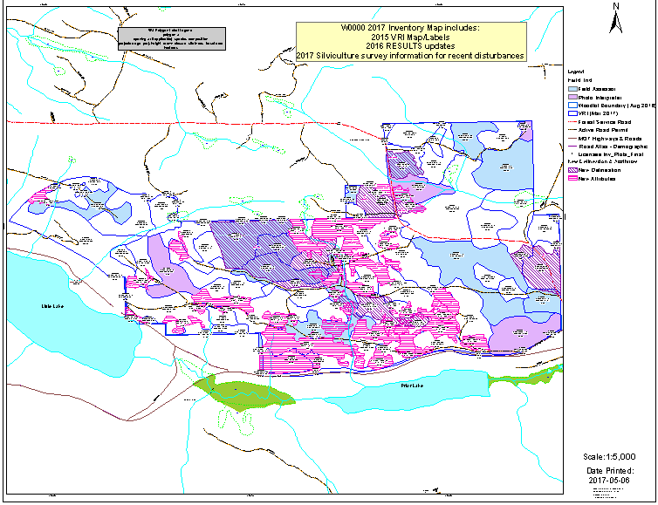

- Georeferenced spatial and attribute data set (shapefile) of new inventory

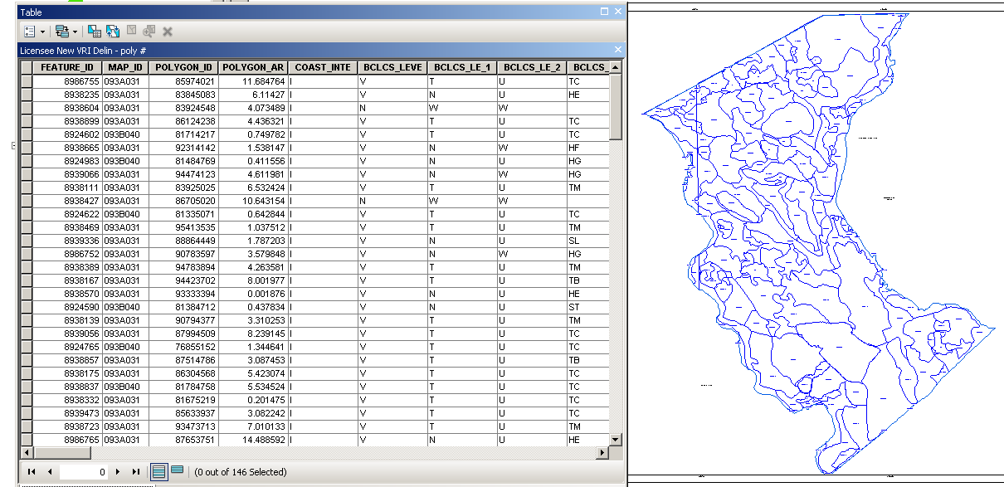

- Summary table of key attributes – identify new and/or updated data
(include all polygons – this example only shows a few)

Mapsheet | Polygon  N = new; U = updated  D = delineation; A = attributes | Gross Area | Species Composition | Age | Height | DBH | Site Index | Basal Area | Live Stems/ha
93A022 | 82204827 | 68 | FDI80SX20 | 119 | 32.5 | 44.3 | 20.4 | 32 | 208
93A022 | NDA102 | 5 | PLI60FDI30SX10 | 1 | 0.2 |  | 18 |  | 1200
93A023 | UA86705020 | 29 | SX90ATI10 | 77 | 23.4 | 34.2 | 18.8 | 48 | 523
93A023 | NDUA87050 | 30 | PL70FDI30 | 14 | 10.4 | 7 | 19 |  | 925
93A023 | 860020 | 45 | FD40SX40AT20 | 78 | 23 | 29.4 | 18.6 | 42 | 619
93A023 | 867243 | 17 | SX100 | 151 | 32.9 | 47 | 17.6 | 24 | 138
93A023 | 99999913 | 2 | wetland

- Sample Plan – recommended to submit initial plan for review prior to fieldwork; post fieldwork, initial plan to be submitted as part of inventory products – actual plot locations & fieldwork description covered in Inventory Work Summaries

Example 2 (Jane Forester)
- Planned Fieldwork Description:
- Type(s): full measure plots count plots other - please specify:
- Amount (# of plots for each type): 27
- Polygons to be visited (how many?): 9
- Attributes to be collected (how?): Variable radius plots will be established with a BAF selected to capture 6-8 trees per plot - 1 BAF per polygon. A minimum of 1 suitable sample tree will be selected at each plot with a minimum of 3 per polygon. Data collection as per standards in 2018 Woodlot Inventory Handbook.
- Rationale used to visit all or only a selection of polygons: Based on the Jul 5, 2017 Inventory Assessment Report, only mature spruce polygons are selected for additional fieldwork. The young pine stands are part of the fall 2017 silviculture surveys.
- Planned plot locations: see attached map (may be amended during field work)
Blue dots & lines are planned plot and traverse line locations

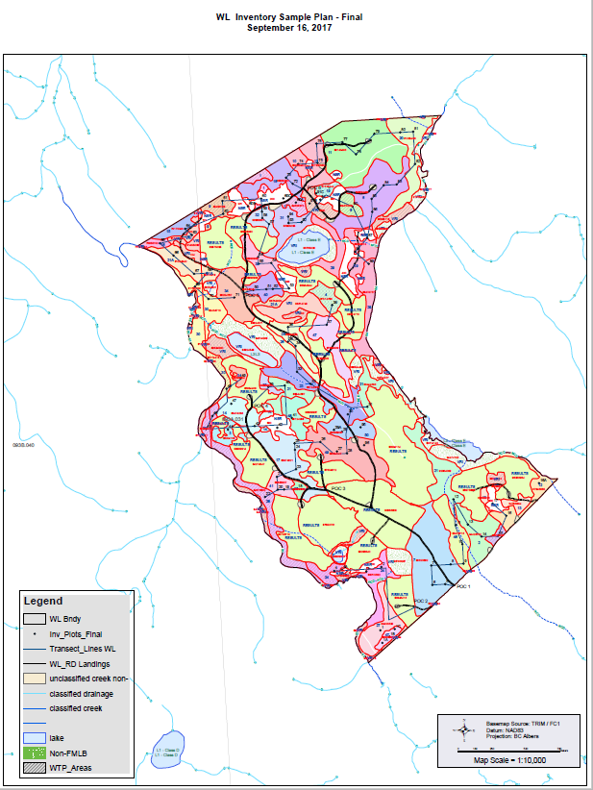

- Imagery showing polygon delineation
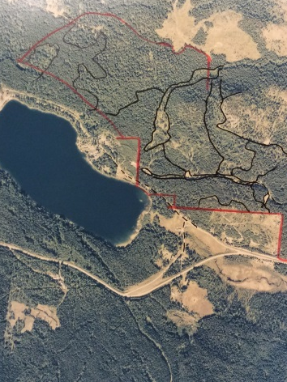
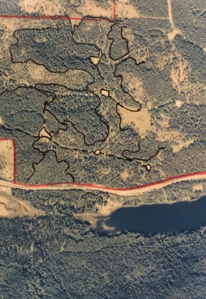
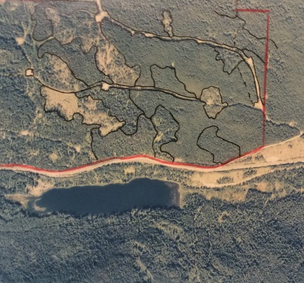
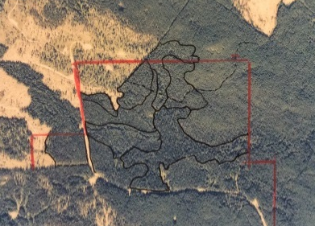

- Plot cards

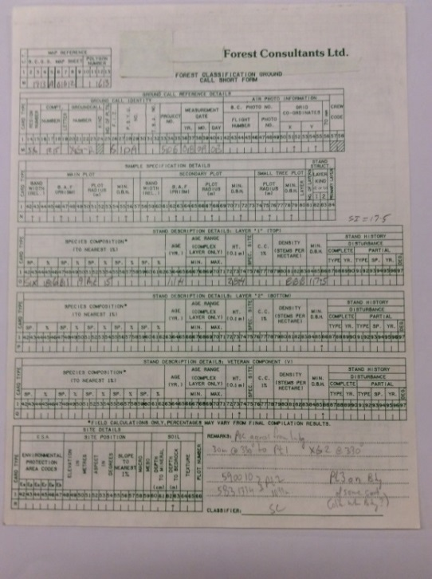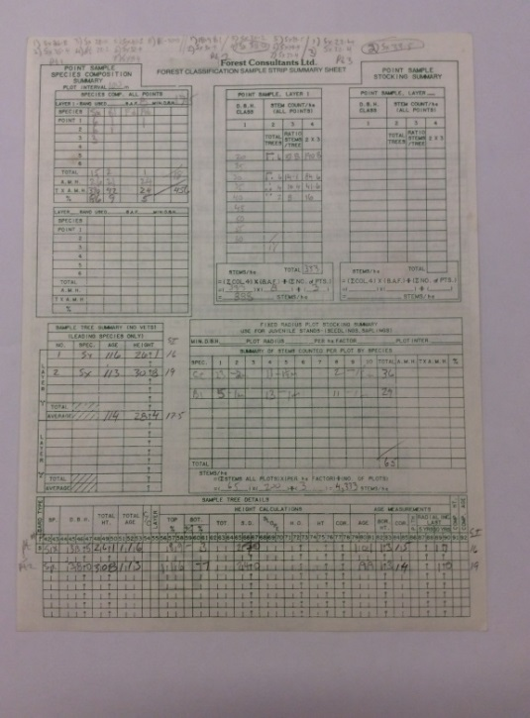

- Georeferenced data set (shapefile) of actual measured field plot locations

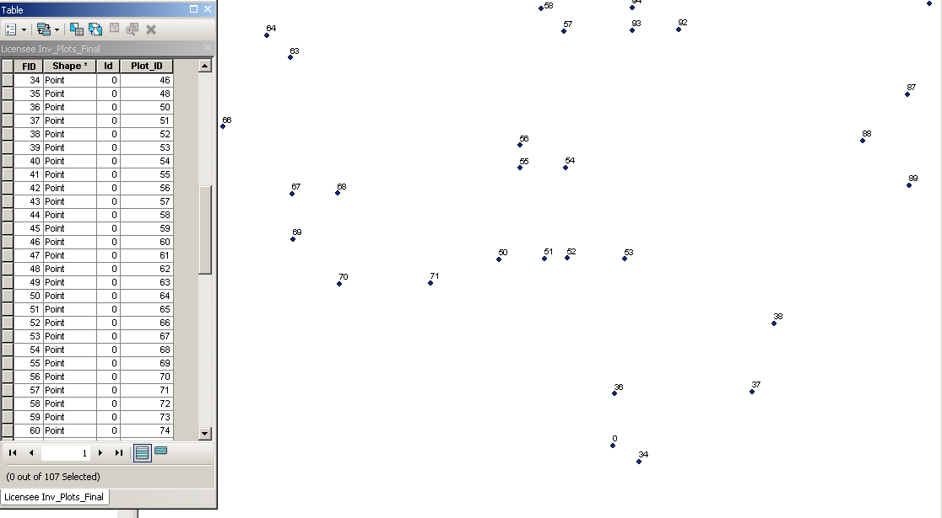

- Summary table of polygon attributes & list of plots used to derive those attributes

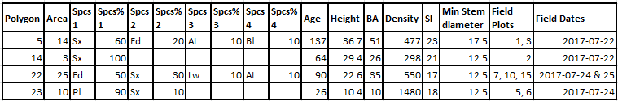

- Excel table listing old and new data for all polygons with changed attributes (or can be shown on a map, as per option in Inventory Work Summaries examples)

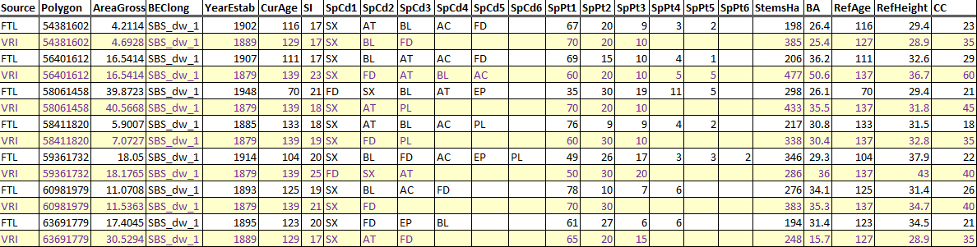

Inventory Work Summaries attached map example:
Purple fill = polygons with changed attributes

- If available, georeferenced PDF map & spatial/attribute date set of existing inventory - See examples under #3 and #4 above.

Inventory Products – map attachment examples (for Inventory Work Summaries above)
- Polygon Delineation Summary – attached map example
See Inventory Work Summaries - Polygon Delineation Summary examples above
Attached map example:
orange = polygons visited by photo interpreter
red crosshatch = polygon delineations that significantly changed

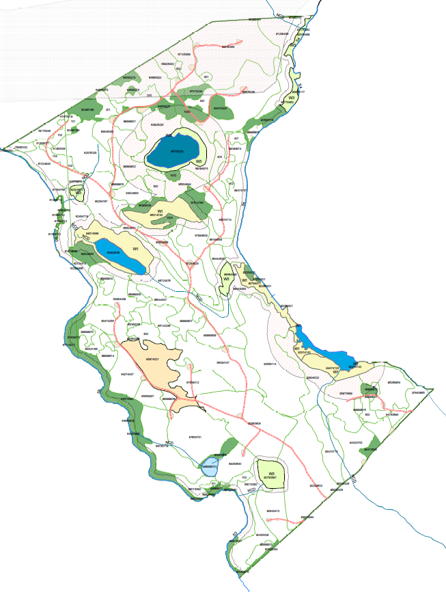

- Polygon Attribute Assignment Summary – attached map example
See Inventory Work Summaries - Polygon Attribute Assignment Summary examples above
Attached map example:
purple = polygons visited by photo interpreter
green = polygons visited by field assessor
red outline = polygon attributes that significantly changed

Cross Reference between
Inventory Products list above and list of Supporting Documents in Inventory Handbook

Inventory Handbook Section 5.2.2  Supporting documents # | Inventory Work Summaries – Example:  Inventory  Products List # | Name of document – note: all items are not necessarily required  (for full descriptions and specific details – see Inventory Handbook)
1 | 1 | Inventory Assessment Report
2 | 2 | Inventory Plan
3 | 6 | Sample Plan
4 | * | Air photo interpretation info
5 | 7 | Copies of imagery used for photo interpretation
6 | 10 | Summary table of polygon attributes & list of plots used to derive those attributes
7 | 8 | Copies of plot cards
8 | 9 | Georeferenced spatial data file of measured plot locations and id numbers
9 | 4 | Georeferenced spatial & attribute data set (shapefile) of new timber inventory
10 | 5 | Excel table of inventory attributes by polygon – id any spatial or attribute changes
11 | 11 | Excel table listing old vs new attribute info by polygon for all polys with changes
12 | 3 | Georeferenced pdf map of new timber inventory
13 | ^ | Paper plot of above map
14 | 12 | Existing Inventory georeferenced pdf map and spatial data file, if available
* info included in Inventory Work Summaries page under Polygon Delineation and/or Attribute Summary
^ not required in DCC as use own plotter to print hard copy = save licensees $

